南华大学公共卫生学院研究生导师简介

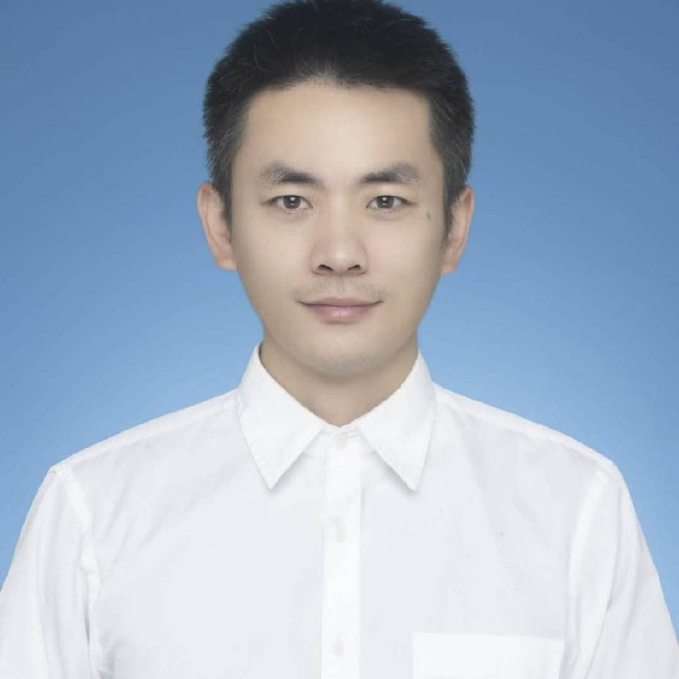 | 姓 名： | 曹毅
 | 出生日期： | 1983年3月
 | 学 位： | 博士
 | 工作单位： | 南华大学公共卫生学院
 | 职称/职务： | 校聘教授
 | 籍 贯： | 湖南省长沙市
 | 研究方向： | 纳米毒理学

一、基本情况
2006年6月毕业于华中师范大学生命科学学院生物技术专业，获得理学学士学位，2009年6月毕业于华中师范大学生命科学学院生物化学与分子生物学专业，获得理学硕士学位，2009-2010年曾进入丹麦奥尔胡斯大学公共卫生学院担任研究助理。2010年6月获得丹麦哥本哈根大学提供的博士奖学金，在哥本哈根大学公共卫生学院攻读生物医学专业攻读博士学位，并于2013年12月获得哲学博士学位。2014年-2015年分别在丹麦哥本哈根大学公共卫生学院和药学院担任博士后。2015年9月全职回国，在湘潭大学化学学院药学专业担任专任教师。2020年12月起在南华大学公共卫生学院从事教学与科研工作（第一类博士引进）。主持国家自然科学基金青年项目和湖南省自然科学基金青年项目各一项，在专业top期刊例如Nanotoxicology, Food and Chemical Toxicology, Journal of Hazardous Materials等发表论文八十余篇，其中回国独立开展工作以来发表论文六十余篇，出版英文书章两篇，担任《Journal of Applied Toxicology》《BIOCELL》《Frontiers in Bioengineering and Biotechnology》等期刊客座编辑，担任《PLOS ONE》《中国化学快报Chinese Chemical Letters》《BIOCELL》等期刊编委或者青年编委，受邀成为Nanotoxicology, Food and Chemical Toxicology, Journal of Hazardous Materials, Toxicology, Toxicology Letters, Chinese Chemical Letters, Environmental Pollution等三十余本专业期刊独立审稿人。

二、教学与科研情况
(一) 科研项目
国家自然科学基金青年项目，“纳米颗粒对泡沫细胞的诱导作用及其分子机理的研究”，2018-2020，金额25万，主持
湖南省自然科学基金青年项目，“食品成分与纳米颗粒的相互作用及其对纳米颗粒安全性的影响”，2018-2020，金额5万，主持

（二）成果、奖项与论文
1、代表性科研论文：
Yi Cao*. Potential roles of Kruppel-like factors (KLFs) in mediating adverse vascular effects of nanomaterials (NMs): A review. Journal of Applied Toxicology, in press, 10.1002/jat.4172.
Yingmei Luo, Xuefeng Wang, Yi Cao*. Transcriptomic analysis suggested the involvement of impaired lipid droplet biogenesis in graphene oxide-induced cytotoxicity in human umbilical vein endothelial cells. Chemico-Biological Interactions, 2021, 333:109325.
Shuang Li, Xuejun Zheng, Chaobo Huang, Yi Cao*. Titanate nanofibers reduce Kruppel-like factor 2 (KLF2)-eNOS pathway in endothelial monolayer: a transcriptomic study. Chinese Chemical Letters, 2021, 32:1569-1572.
Yi Cao*, Shuang Li, Jiamao Chen. Modeling better in vitro models for the prediction of nanoparticle toxicity: a review. Toxicology Mechanisms and Methods, 2021, 31:1-17.
Shuyi Wang, Jing Ma, Shuai Guo, Yuanyu Huang*, Yi Cao*. Transcriptomic analysis revealed that multi-walled carbon nanotubes diameter-dependently induced pyroptosis in THP-1 macrophages. NanoImpact, 2020, 20:100270.
Ying Jiang#, Housheng Gong#, Shaohua Jiang, Chaowen She*, Yi Cao*. Multi-walled carbon nanotubes decrease neuronal NO synthase in 3D brain organoids. Science of the Total Environment, 2020, 748:141384.
Ting Yang#, Jiamao Chen#, Lingqiang Gao, Yuanyu Huang, Guochao Liao*, Yi Cao*. Induction of lipid droplets in THP-1 macrophages by multi-walled carbon nanotubes in a diameter-dependent manner: a transcriptomic study. Toxicology Letters, 2020, 332:65-73.
Junkang Wang#, Jiaqi Zhang#, Shuang Li, Chaobo Huang, Yixi Xie*, Yi Cao*. Anthocyanins decrease the internalization of TiO2 nanoparticles into 3D Caco-2 spheroids. Food Chemistry, 2020, 331:127360.
Bihan Wu#, Mengdie Jiang#, Xuewu Liu, Chaobo Huang, Zhipeng Gu*, Yi Cao*. Evaluation of toxicity of halloysite nanotubes and multi-walled carbon nanotubes to endothelial cells in vitro and blood vessels in vivo. Nanotoxicology, 2020, 14:1017-1038.
Yingmei Luo, Jinfeng Peng*, Chaobo Huang, Yi Cao*. Graphene oxide size-dependently altered lipid profiles in THP-1 macrophages. Ecotoxicology and Environmental Safety, 2020, 199:110714
Jinru Lin#, Ying Jiang#, Yingmei Luo, Hao Guo, Chaobo Huang, Jinfeng Peng*, Yi Cao*. Multi-walled carbon nanotubes (MWCNTs) transformed THP-1 macrophages into foam cells: impact of pulmonary surfactant component dipalmitoylphosphatidylcholine. Journal of Hazardous Materials, 2020, 392:122286.
Shuang Li#, Hongji Liu#, Zhengzheng Zhou*, Yi Cao*. Titanate nanotubes at non-cytotoxic concentrations affect NO signaling pathway in human umbilical vein endothelial cells. Toxicology in Vitro, 2020, 62:104689.
Yi Cao*, Yingmei Luo. Pharmacological and toxicological aspects of carbon nanotubes (CNTs) to vascular system: a review. Toxicology and Applied Pharmacology, 2019, 385:114801.
Jing Li#, Haiyin Yang#, Suinan Sha, Jiaquan Li, Zhengzheng Zhou*, Yi Cao*. Evaluation of in vitro toxicity of silica nanoparticles (NPs) to lung cells: influence of cell types and pulmonary surfactant component DPPC. Ecotoxicology and Environmental Safety, 2019, 186:109770.
Xianqiang Li#, Yuanfang Tang#, Chunying Chen, Dexin Qiu*, Yi Cao*. PEGylated gold nanorods are not cytotoxic to human endothelial cells but affect kruppel-like factor signaling pathway. Toxicology and Applied Pharmacology, 2019, 382:114758.
Jimin Long, Wen Ma, Zhiqiang Yu, Hongwen Liu*, Yi Cao*. Multi-walled carbon nanotubes (MWCNTs) promoted lipid accumulation in THP-1 macrophages through modulation of endoplasmic reticulum (ER) stress. Nanotoxicology, 2019, 13:938-951.
Haiyin Yang#, Jing Li#, Chunguang Yang, Hongwen Liu*, Yi Cao*. Multi-walled carbon nanotubes promoted lipid accumulation in human aortic smooth muscle cells. Toxicology and Applied Pharmacology, 2019, 374:11-19.
Qianyu Yang#, Maolin Wang#, Yongbing Sun, Shengming Peng, Yanhuai Ding*, Yi Cao*. Pre-incubated with BSA-complexed free fatty acids alters ER stress/autophagic gene expression by carboxylated multi-walled carbon nanotube exposure in THP-1 macrophages. Chinese Chemical Letters, 2019, 30:1224-1228.
Pantian Zhang, Pan She, Jiahui He, Zexing Xiang, Zhaocheng Li, Yi Cao*, Xuefei Zhang*. Full-biodegradable polylactide-based thermoresponsive copolymer with a wide temperature range: Synthesis, characterization and thermoresponsive properties. Reactive and Functional Polymers, 2019, 142:128-133.
Leying Jiang#, Zhen Li#, Yixi Xie, Liangliang Liu*, Yi Cao*. Cyanidin chloride modestly protects Caco-2 cells from ZnO nanoparticle exposure probably through the induction of autophagy. Food and Chemical Toxicology, 2019, 127: 251-259.
Yongqi Liang#, Min Xie#, Juan Li, Liangliang Liu*, Yi Cao*. Influence of 3-hydroxyflavone on colloidal stability and internationalization of Ag nanomaterials. Dose Response, 2019, 17 (3): 1559325819865713.
Jiahui He, Wei Wang, Huicong Zhou, Pan She, Pantian Zhang, Yi Cao*, XuefeiZhang*. A novel pH-sensitive polymeric prodrug was prepared by SPAAC click chemistry for intracellular delivery of doxorubicin and evaluation of its anti-cancer activity in vitro. Journal of Drug Devliery Science and Technology, 2019, 53:101130.
Xuqi Zhao#, Shiwei Chang#, Jimin Long, Juan Li, Xianqiang Li*, Yi Cao*. The toxicity of multi-walled carbon nanotubes (MWCNTs) to human endothelial cells: the influence of diameters of MWCNTs. Food and Chemical Toxicology, 2019, 126:169-177.
Ting Liu#, Hongying Liang#, Liangliang Liu, Yu Gong, Yanhuai Ding, Guochao Liao*, Yi Cao*. Influence of pristine and hydrophobic ZnO nanoparticles on cytotoxicity and endoplasmic reticulum (ER) stress-autophagy-apoptosis gene expression in A549-macrophage co-culture. Ecotoxicology and Environmental Safety, 2019, 167:188-195.
Zhen Li#, Ting Liu#, Jimin Long, Yang Wu, Biao Yan, Ping Ma*, Yi Cao*. The toxicity of hydroxylated and carboxylated multi-walled carbon nanotubes to human endothelial cells was not exacerbated by ER stress inducer. Chinese Chemical Letters, 2019, 30:582-586.
Jiamao Chen#, Ting Yang#, Jimin Long, Yanhuai Ding, Juan Li, Xianqiang Li*, Yi Cao*. Palmitate enhanced the cytotoxicity of ZnO nanomaterials possibly by promoting endoplasmic reticulum (ER) stress. Journal of Applied Toxicology, 2019, 39:798-806.
Dejian Yan#, Jimin Long#, Jikai Liu*, Yi Cao*. The toxicity of ZnO nanomaterials to HepG2 cells: the influence of size and shape of particles. Journal of Applied Toxicology, 2019, 39:231-240.
Yi Cao#, Ziyin Li#, Lianzhi Mao, Hehe Cao, Jingjing Kong, BinYu, Changmin Yu*, Wenzhen Liao*. The use of proteomic technologies to study molecular mechanisms of multidrug resistance in cancer. European Journal of Medicinal Chemistry, 2019, 162:423-434.
Mengdie Jiang#, Bihan Wu#, Yongbing Sun, Yanhuai Ding, Yixi Xie, Liangliang Liu*, Yi Cao*. Toxicity of ZnO nanoparticles (NPs) to THP-1 macrophages: interactions with saturated or unsaturated free fatty acids. Toxicology Mechanisms and Methods, 2019, 29:291-299.
Maolin Wang#, Qianyu Yang#, Jimin Long, Yanghuai Ding, Xiaoqing Zou, Guochao Liao*, Yi Cao*. A comparative study of toxicity of TiO2, ZnO and Ag nanoparticles to human aortic smooth muscle cells. International Journal of Nanomedicine, 2018, 13:8037-8049.
Chunxue Zhao#, Yiwei Zhou#, Liangliang Liu, Jimin Long, Hongwen Liu, Juan Li*, Yi Cao*. Lipid accumulation in multi-walled carbon nanotube-exposed HepG2 cells: possible role of lipophagy pathway. Food and Chemical Toxicology, 2018, 121C:65-71.
Shiwei Chang#, Xuqi Zhao#, Siyu Li, Tuqiang Liao, Jimin Long, Zhiqiang Yu*, Yi Cao*. Cytotoxicity, cytokine release and ER stress-autophagy gene expression in endothelial cells and alveolar-endothelial co-culture exposed to pristine and carboxylated multi-walled carbon nanotubes. Ecotoxicology and Environmental Safety, 2018, 161:569-577.
Hongying Liang#, Tong He#, Jimin Long, Liangliang Liu, Guochao Liao, Yanhuai Ding*, Yi Cao*. Influence of bovine serum albumin pre-incubation on toxicity and ER stress-apoptosis gene expression in THP-1 macrophages exposed to ZnO nanoparticles. Toxicology Mechanisms and Methods, 2018, 28: 587-598.
Yi Cao*, Yu Gong, Wenzhen Liao*, Yunfeng Luo, Chaohua Wu, Maolin Wang, Qianyu Yang. A review of cardiovascular toxicity of TiO2, ZnO and Ag nanoparticles (NPs). BioMetals, 2018, 31:457-476.
Yunfeng Luo#, Chaohua Wu#, Liangliang Liu, Yu Gong, Shengming Peng, Yixi Xie*, Yi Cao*. 3-Hydroxyflavone enhances the toxicity of ZnO nanoparticles (NPs) in vitro. Journal of Applied Toxicology, 2018, 38:1206-1214.
Cao Zhang#, Yining Li#, Liangliang Liu, Yu Gong, Yixi Xie*, Yi Cao*. Chemical Structures of Polyphenols That Critically Influence the Toxicity of ZnO Nanoparticles. Journal of Agricultural and Food Chemistry, 2018, 66:1714-1722.
Yining Li#, Cao Zhang#, Liangliang Liu, Yu Gong, Yixi Xie*, Yi Cao*. The effects of baicalein or baicalin on the colloidal stability of ZnO nanoparticles (NPs) and toxicity of NPs to Caco-2 cells. Toxicology Mechanisms and Methods, 2018, 28:167-176.
Yuexin Shen#, Gui Chen#, Aiping Xiao, Yixi Xie, Liangliang Liu*, Yi Cao*. In vitro effect of flaxseed oil and α-linolenic acid against the toxicity of lipopolysaccharide (LPS) to human umbilical vein endothelial cells. Inflammopharmacology, 2018, 26:645-654.
Wei Wang, Biyun Zhao, Xiangyang Meng, Pan She, Pantian Zhang, Yi Cao*, Xuefei Zhang*. Preparation of dual-drug conjugated polymeric micelles with synergistic anti-cancer efficacy in vitro. Journal of Drug Delivery Science and Technology, 2018, 43:388-396.
Jimin Long, Yafang Xiao, Liangliang Liu*, Yi Cao*. The adverse vascular effects of multi-walled carbon nanotubes (MWCNTs) to human vein endothelial cells (HUVECs) in vitro: role of length of MWCNTs. Journal of Nanobiotechnology, 2017, 15:80.
Tong He, Jimin Long, Juan Li, Liangliang Liu*, Yi Cao*. Toxicity of ZnO nanoparticles (NPs) to A549 cells and A549 epithelium in vitro: interactions with dipalmitoyl phosphatidylcholine (DPPC). Environmental Toxicology and Pharmacology, 2017, 56:233-240.
Xin Fang#, Leying Jiang#, Yu Gong, Juan Li, Liangliang Liu*, Yi Cao*. The presence of oleate stabilized ZnO nanoparticles (NPs) and reduced the toxicity of aged NPs to Caco-2 and HepG2 cells. Chemico-Biological Interactions, 2017, 278:40-47.
Yu Gong, Liangliang Liu, Juan Li*, Yi Cao*. The presence of palmitate affected the colloidal stability of ZnO NPs but not the toxicity to Caco-2 cells. Journal of Nanoparticle Research, 2017, 19:335.
Haikang Huang, Jing Yan , Pei Liu , Biyun Zhao , Yi Cao*, Xuefei Zhang*. A novel cancer nanotheranostics system based on quantum dots encapsulated by polymer-prodrug with controlled release behaviour. Australian Journal of Chemistry, 2017, 70:1302-1311.
Yi Cao*, Jimin Long, Liangliang Liu, Tong He, Leying Jiang, Chunxue Zhao, Zhen Li. A review of endoplasmic reticulum (ER) stress and nanoparticle (NP) exposure. Life Sciences, 2017, 186:33-42.
Yiwei Zhou#, Xin Fang#, Yu Gong, Aiping Xiao, Yixi Xie, Liangliang Liu*, Yi Cao*. The Interactions between ZnO Nanoparticles (NPs) and α-Linolenic Acid (LNA) Complexed to BSA Did Not Influence the Toxicity of ZnO NPs on HepG2 Cells. Nanomaterials (Basel), 2017, 7(4): 91.
Yi Cao*, Yu Gong, Liangliang Liu, Yiwei Zhou, Xin Fang, Cao Zhang, Yining Li, Juan Li. The use of human umbilical vein endothelial cells (HUVECs) as an in vitro model to assess the toxicity of nanoparticles to endothelium: a review. Journal of Applied Toxicology, 2017, 37:1359-1369.
Yu Gong, Yuejia Ji, Fang Liu, Juan Li*, Yi Cao*. Cytotoxicity, oxidative stress and inflammation induced by ZnO nanoparticles in endothelial cells: interaction with palmitate or lipopolysaccharide. Journal of Applied Toxicology, 2017, 37: 895-901.
Yi Cao*, Yixi Xie*, Liangliang Liu, Aiping Xiao, Yining Li, Cao Zhang, Xin Fang, Yiwei Zhou. Influence of phytochemicals on the biocompatibility of inorganic nanoparticles: a state-of-the-art review. Phytochemistry Reviews, 2017, 16: 555-563.
Yuxiu Gu#, Shanshan Cheng#, Gui Chen, Yuexin Shen, Xiyue Li, Qin Jiang, Juan Li*, Yi Cao*. The effects of endoplasmic reticulum stress inducer thapsigargin on the toxicity of ZnO or TiO2 nanoparticles to human endothelial cells. Toxicology Mechanisms and Methods, 2017, 27: 191-200.
Gui Chen#, Yuexin Shen#, Xiyue Li, Qin Jiang, Shanshan Cheng, Yuxiu Gu, Liangliang Liu*, Yi Cao*. The endoplasmic reticulum stress inducer thapsigargin enhances the toxicity of ZnO nanoparticles to macrophages and macrophage-endothelial co-culture. Environmental Toxicology and Pharmacology, 2017, 50: 103-110.
Fang Liu, Haikang Huang, Yu Gong, Juan Li, Xuefei Zhang*, Yi Cao*. Evaluation of in vitro toxicity of polymeric micelles to human endothelial cells under different conditions. Chemico-Biological Interactions, 2017, 263:46-54.
Qin Jiang#, Xiyue Li#, Shanshan Cheng, Yuxiu Gu, Gui Chen, Yuexin Shen, Yixi Xie, Yi Cao*. Combined effects of low levels of palmitate on toxicity of ZnO nanoparticles to THP-1 macrophages. Environmental Toxicology and Pharmacology, 2016, 48:103-109.
Yi Cao*, Jimin Long, Yuejia Ji, Gui Chen, Yuexin Shen, Yu Gong , Juan Li. Foam cell formation by particulate matter (PM) exposure: a review. Inhalation Toxicology, 2016, 28(13):583-590.
Yi Cao*, Juan Li, Fang Liu, Xiyue Li, Qin Jiang, Shanshan Cheng, Yuxiu Gu. Consideration of interaction between nanoparticles and food components for the safety assessment of nanoparticles following oral exposure: A review. Environmental Toxicology and Pharmacology, 2016, 46:206-210.
Yi Cao, Martin Roursgaard, Nicklas Raun Jacobsen, Peter Møller, Steffen Loft. Monocyte adhesion induced by multi-walled carbon nanotubes and palmitic acid in endothelial cells and alveolar-endothelial co-cultures. Nanotoxicology, 2016, 10(2):235-244.
Yi Cao*, Kim Jantzen, Ana Cecilia Damiao Gouveia, Astrid Skovmand, Martin Roursgaard, Steffen Loft, Peter Møller. Automobile diesel exhaust particles induce lipid droplet formation in macrophages in vitro. Environmental Toxicology and Pharmacology, 2015, 56(2):97-110.
Yi Cao*, Dorthe A. Bindslev, Søren K. Kjærgaard. Estimation of the in vitro eye irritating and inflammatory potential of lipopolysaccharide (LPS) and dust by using reconstituted human corneal epithelium tissue cultures. Toxicology Mechanisms and Methods, 2015, 25(5):402-409.
Yi Cao*, Martin Roursgaard, Ali Kermanizadeh, Steffen Loft, Peter Møller. Synergistic effects of zinc oxide nanoparticle and fatty acid on toxicity to Caco-2 cells. International Journal of Toxicology, 2015, 34(1):67-76.
Yi Cao, Martin Roursgaard, Pernille Danielsen, Peter Møller, Steffen Loft. Carbon black nanoparticles promote endothelial activation and lipid accumulation in macrophages independently of intracellular ROS production. PLOS ONE, 2014, 9(9):e106711.
Yi Cao, Nicklas Raun Jacobsen, Pernille Danielsen, Anke G Lenz, Tobias Stoeger, Steffen Loft, Håkan Wallin, Martin Roursgaard, Lone Mikkelsen, Peter Møller. Vascular effects of multi-walled carbon nanotubes in dyslipidemic ApoE-/- mice and cultured endothelial cells. Toxicological Sciences, 2014, 138(1):104-116.
Yi Cao, Sisi Liang, Yuduo Zheng, Dandan Liu, Benyan Zhang, Dongqun Xu, Xu Yang. Induction of GSNO Reductase but not NOS in glucan-Spiked Office Dust Exposed Mice Lungs. Environmental Toxicology, 2011, 26(3):279-86.

2、英文书章：
Yi Cao. The Toxicity of Nanoparticles to Human Endothelial Cells. In Advances in Experimental Medicine and Biology. 2018, Volume 1048, pp:59-69. Editors: Quaiser Saquib, Mohammad Faisal, Abdulaziz A. Al-Khedhairy, Abdulrahman A. Alatar. Published by Springer-Nature.
Yi Cao. Toxicity of Ingested Nanomaterials. In Food Toxicology: Current Advances and Future Challenges. Editors: Ashish Sachan, Suzanne Hendrich. November, 2017 by Apple Academic Press.

三、人才培养
2015年9月至2020年10月，实验室培养本科生48人，本科生以第一作者发表SCI期刊论文33篇，目前本科生毕业32人，大部分进入中国科学院，北京大学，中国药科大等国内知名高校继续深造，有7人选择出国留学，其中3人分别获得美国德州大学Austin分校，Texas A&M大学和澳大利亚莫纳什大学博士全额奖学金。实验室培养研究生4人，已经毕业2人，研究生以第一作者发表SCI期刊论文10篇（不含导师一作的情况）。
主讲本科课程：卫生毒理学、科研设计、预防医学

四、联系方式：
电 话：18607323924
E-mail：caoyi39@126.com

